ASSIGNMENT:
- Pass boolean value inside the if block

class Sample
{
public static void main(String args[])
{
boolean b=true;
if(b)
{
System.out.println("if bolck");
}
else
{
System.out.println("else block");
}
}
}
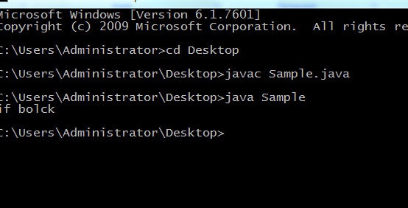

2. Pass nothing inside the if block
class Sample
{
public static void main(String args[])
{
boolean b=true;
if()
{
System.out.println("if bolck");
}
else
{
System.out.println("else block");
}
}
}
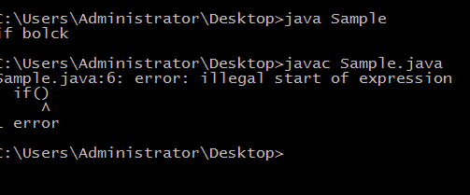
3.Pass integer / double value inside the if block

class Sample
{
public static void main(String args[])
{
int b=10;
double d=1.3;
if(b)
{
System.out.println("int");
}
if(d)
{
System.out.println("double");
}
}
}
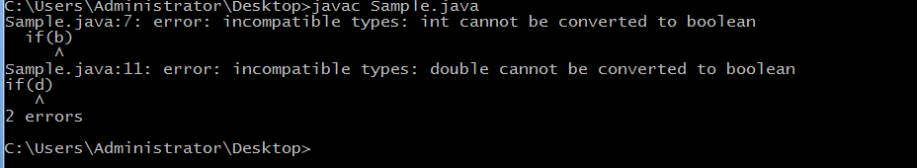

4. Perform assignment operation inside the if statement for boolean data type

class Sample
{
public static void main(String args[])
{
boolean b;
if(b=true)
{
System.out.println("hi");
}
else
{
System.out.println("bye");
}
}
}
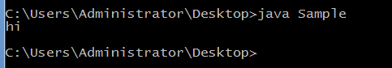

5. Perform assignment operation inside the if statement for integer / double data type

class Sample
{
public static void main(String args[])
{
int a;
double d;
if(a=10)
{
System.out.println("int="+a);
}
if(d=1.2)
{
System.out.println("double="+d);
}
}
}
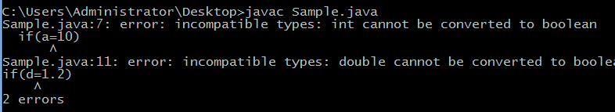

6. Pass boolean value inside the switch block

class Sample
{
public static void main(String args[])
{
boolean a=true;
switch(a)
{
case 1:System.out.println("hi");break;
case 2:System.out.println("hi1");break;
case 3:System.out.println("hi2");break;
}
}
}
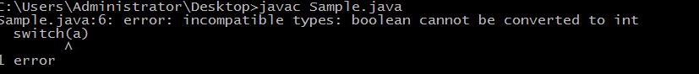

7. Pass nothing inside the switch block
class Sample
{
public static void main(String args[])
{
boolean a=true;
switch()
{
case 1:System.out.println("hi");break;
case 2:System.out.println("hi1");break;
case 3:System.out.println("hi2");break;
}
}
}
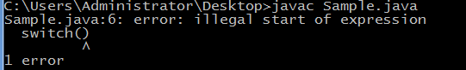

8.1 Pass integer value inside the switch block
class Sample
{
public static void main(String args[])
{
int a=2;
switch(a)
{
case 1:System.out.println("hi");break;
case 2:System.out.println("hi1");break;
case 3:System.out.println("hi2");break;
}
}
}
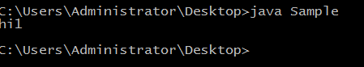

8.2 Pass double value inside the switch block
class Sample
{
public static void main(String args[])
{
double a=2.1;
switch(a)
{
case 1:System.out.println("hi");break;
case 2:System.out.println("hi1");break;
case 3:System.out.println("hi2");break;
}
}
}
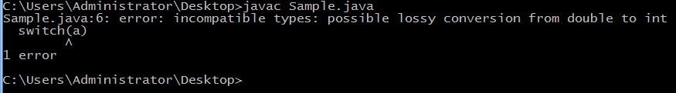

9. Perform assignment operation inside the switch statement.
class Sample
{
public static void main(String args[])
{
int a;
switch(a=1)
{
case 1:System.out.println("hi");break;
case 2:System.out.println("hi1");break;
case 3:System.out.println("hi2");break;
}
}
}
